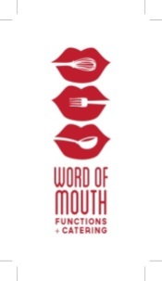

2023 Long Table Wine Luncheon
Murrumbateman Recreation Reserve, Wine Marquee
11.30 am Saturday 30th September 2023

All wines served are Medal Winners from the 2023 Show – ENJOY

Artisan bread and crusty rolls served with butter

To start
Seafood platter
Pots of trout mousse, smoked salmon, fresh prawns, blini, Marie rose and roe

Entree
Wagyu beef slider, brioche bun and aged cheddar
Served with pickled beetroot relish

Main course
Confit duck leg w/ braised cabbage & cherry glaze (gf, df)
Served with braised cabbage and a cherry glaze

Dessert
Hummingbird cake with cream cheese icing
Served with candied pineapple and pecan brittle (n, v)
Cheese
Selection of Cheese and Crackers

*Please email events@accwineshow.com.au with any dietary requests and seating requirements

